|  |
| --- |
|  |
| TRAVELS AGENCY |
| Project Documentation of DISM (Semester II) |

SHAHZINA KHAN

student 1074493

**Faculty** = Miss Aatika Liaquat

**Batch Code** = 1807E1

**Curriculum**= 6673

**Semester**= HDSE-II

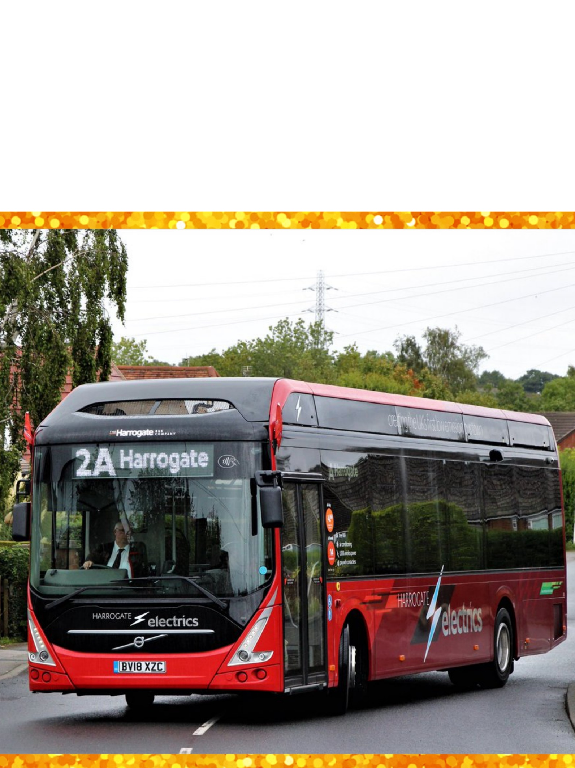

DATABASE

**ADO MODEL**

**MODEL DIAGRAM**

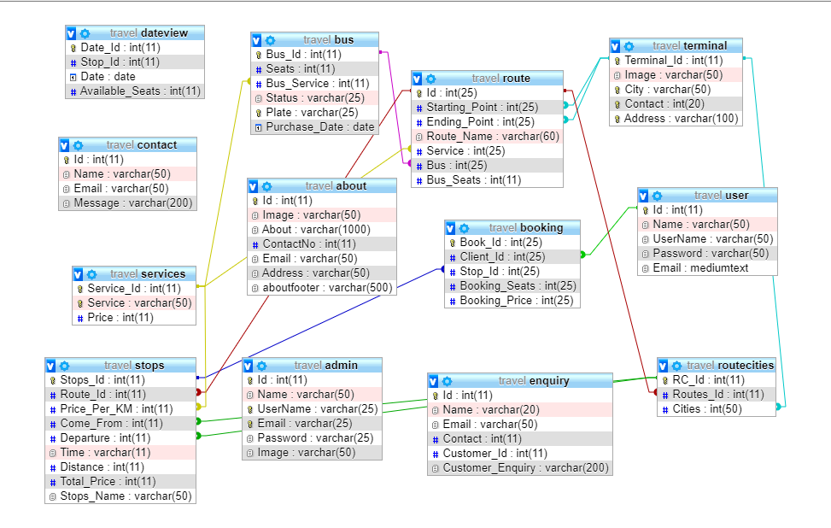

**ADO MODEL**

***Code Snippet***:

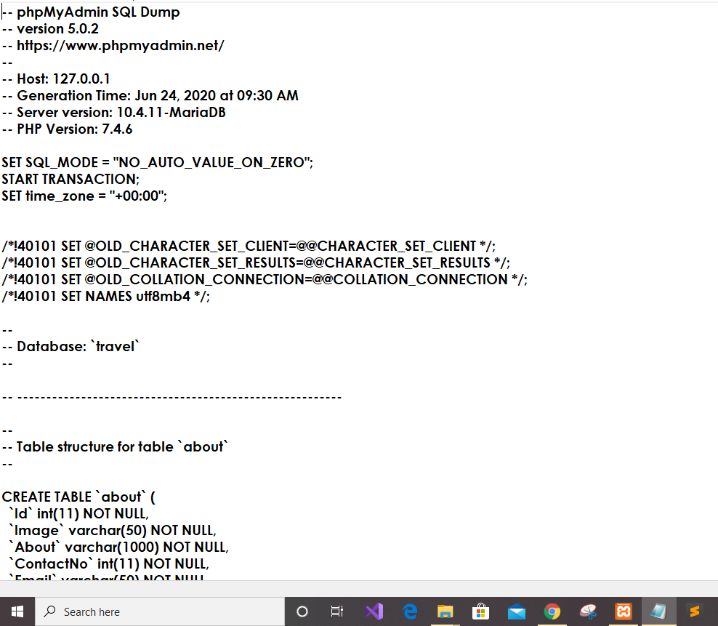

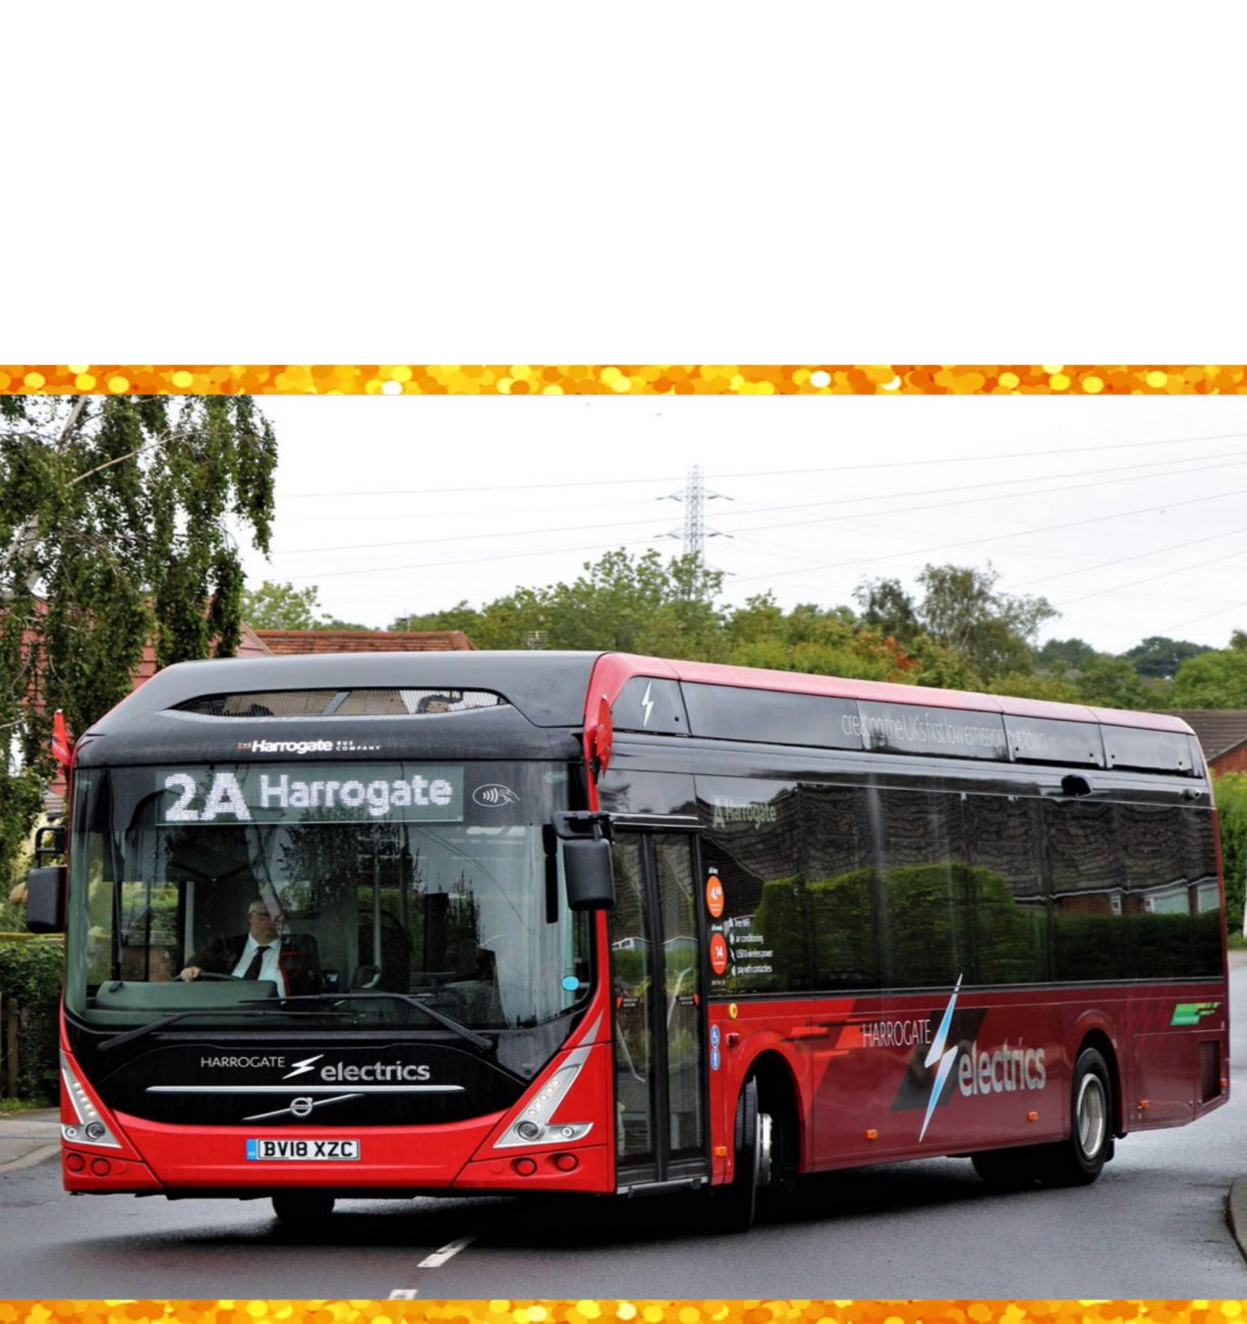

BACKEND

**BACKEND:-**

**Login Page :-**

This is the entry point of our application. First of all you’ll see this page then you can sign in through this and only if your id password matches with the id password in our data base you will proceed to next page .

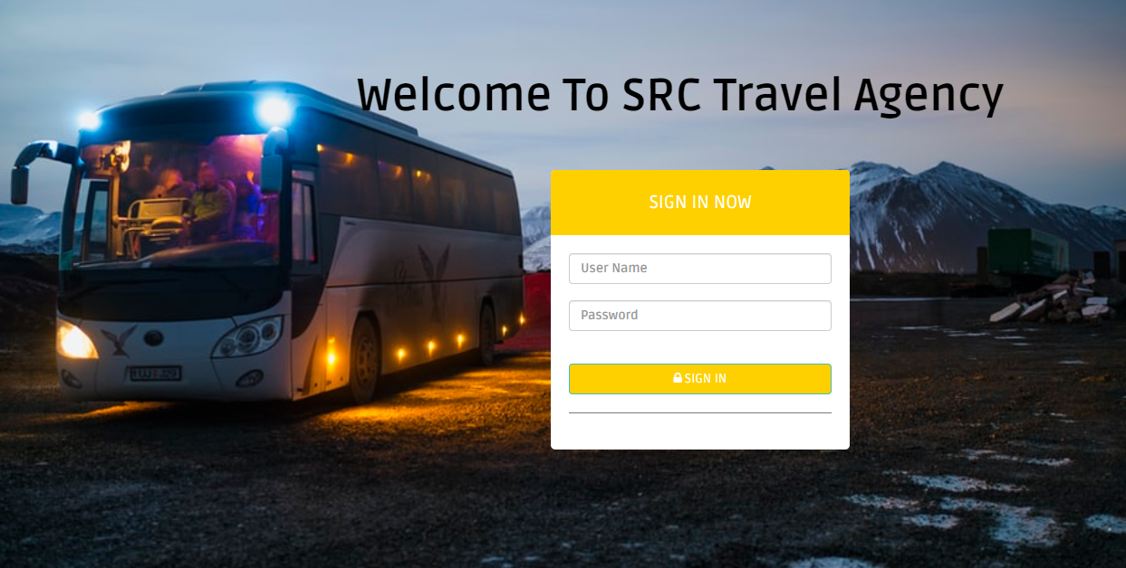

***Code Snippet***:

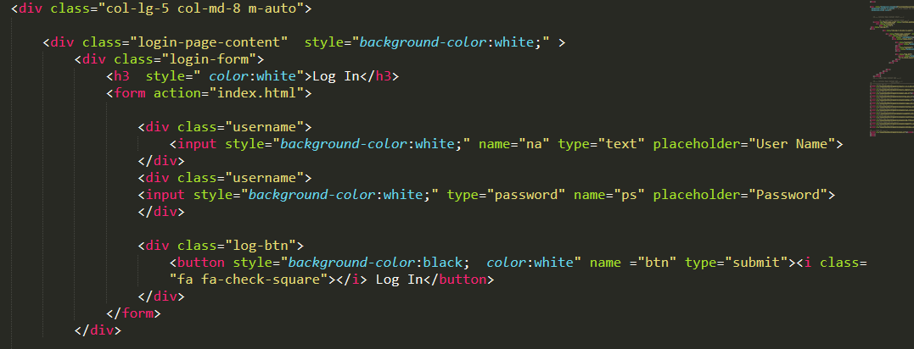 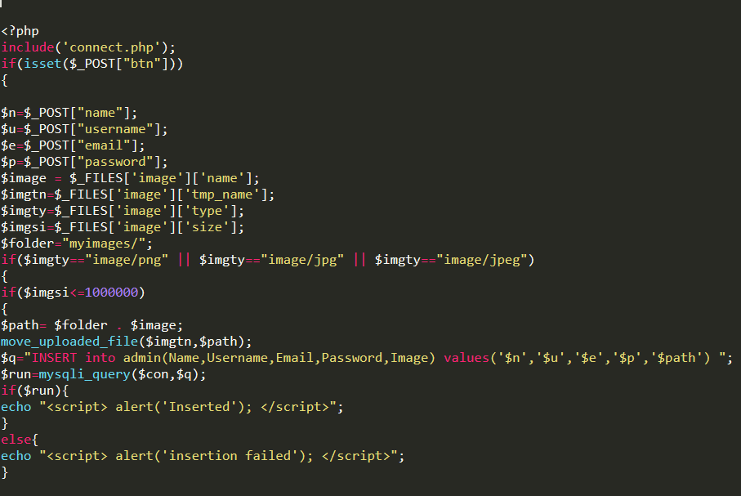

**Dashboard:-**

This is the dashboard from where admin can perform all the CRUD operations. Also can edit layout (Frontend) pages. Admin can see the enquiry box and will be able to respond them.

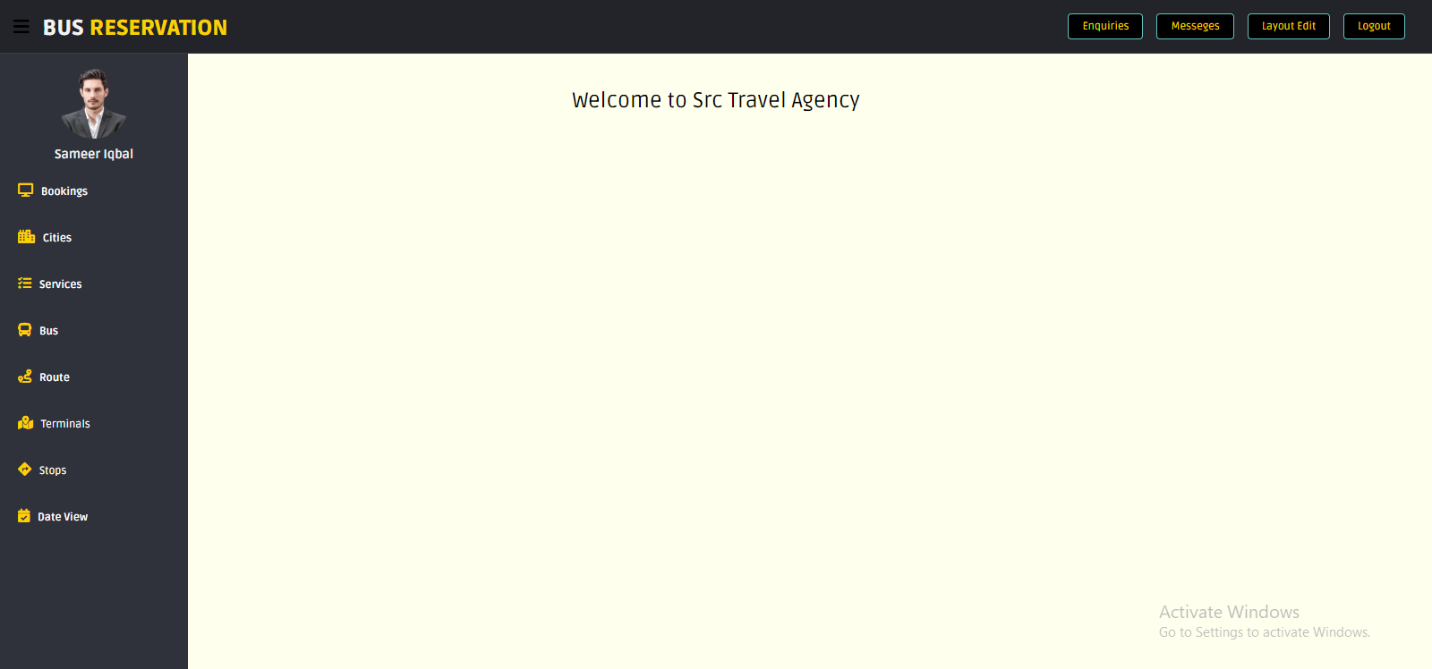

***Code Snippet***:

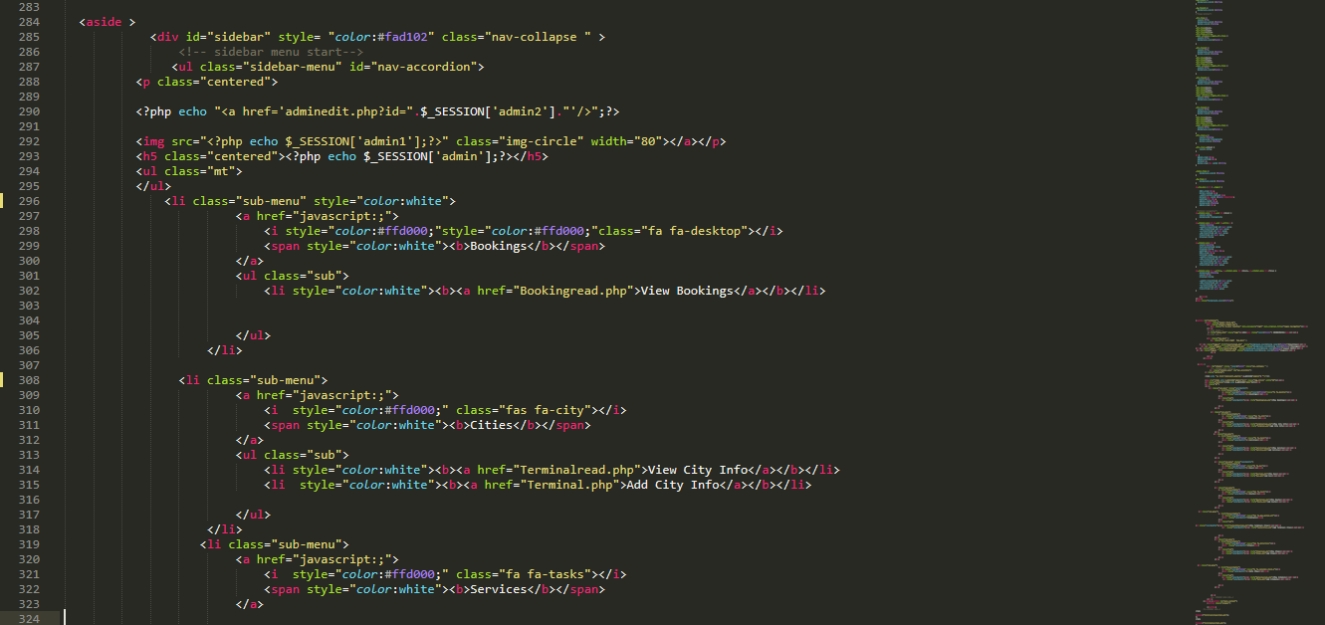

**Route View Page:-**

From where admin can see all the entries which are already inserted. Also Live search is included which helps to make things more easy.

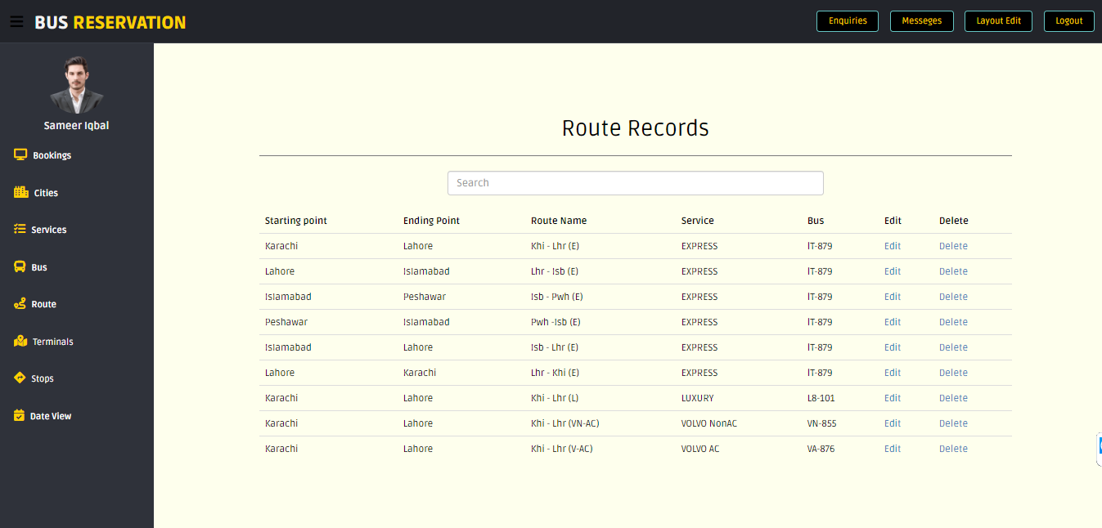

***Code Snippet***:

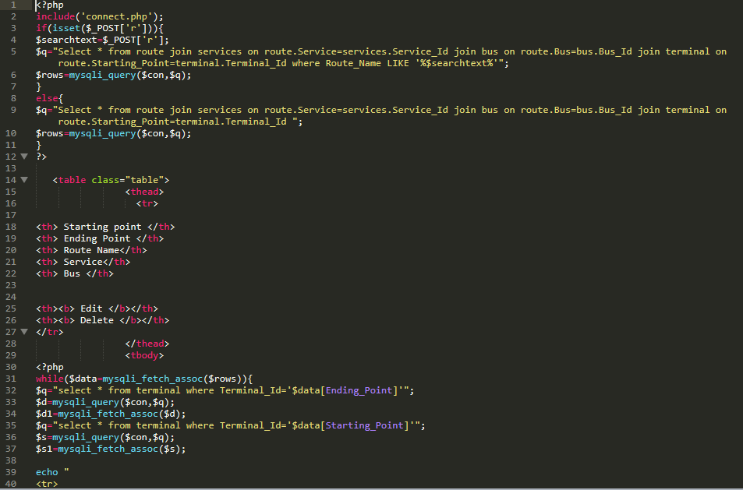

**Route Insert Page:-**

From where admin can insert the entries .

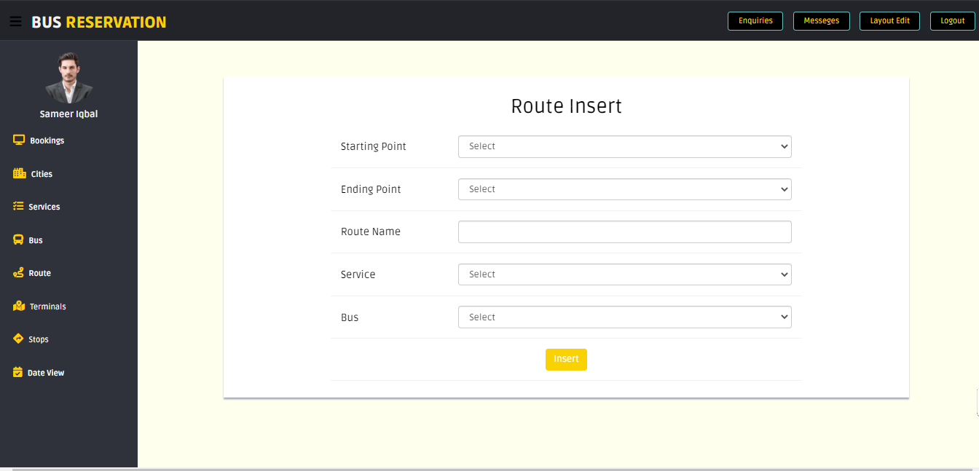

***Code Snippet***:

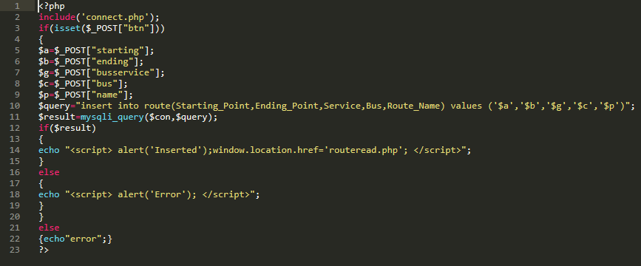

**Route Update Page:-**

From where admin can update the entries which are already inserted.

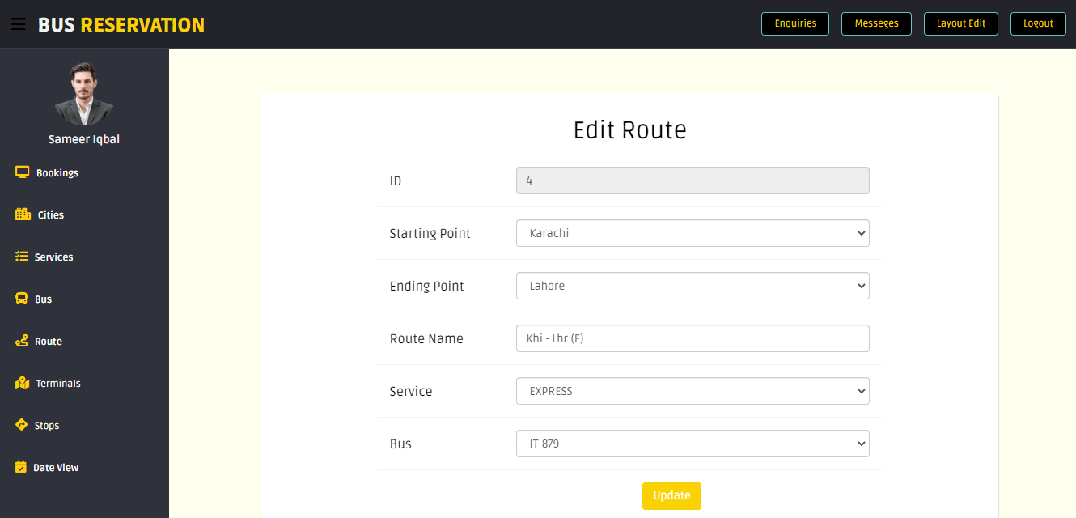

***Code Snippet***:

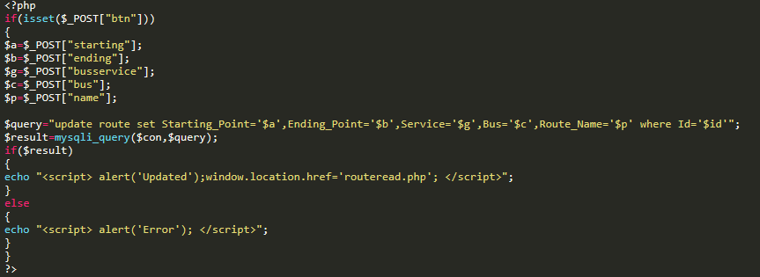

FRONTEND



**FRONTEND**

**Home Page:-**

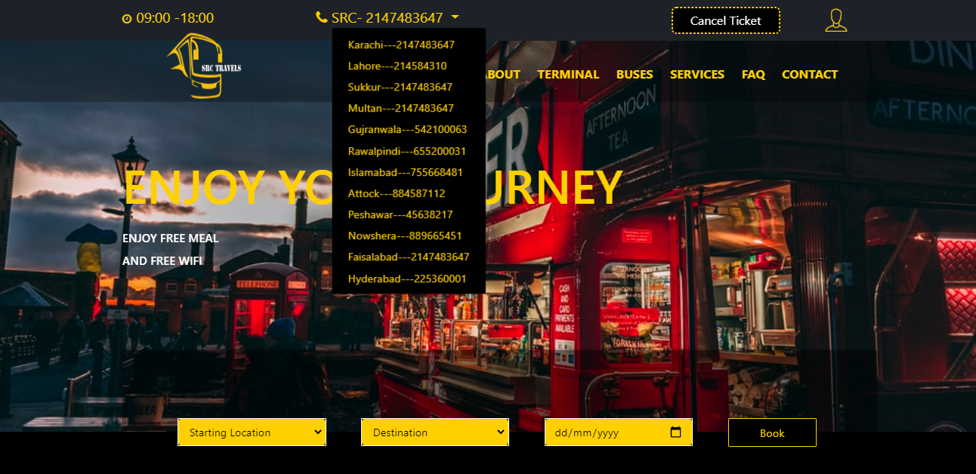

***Code Snippet***:

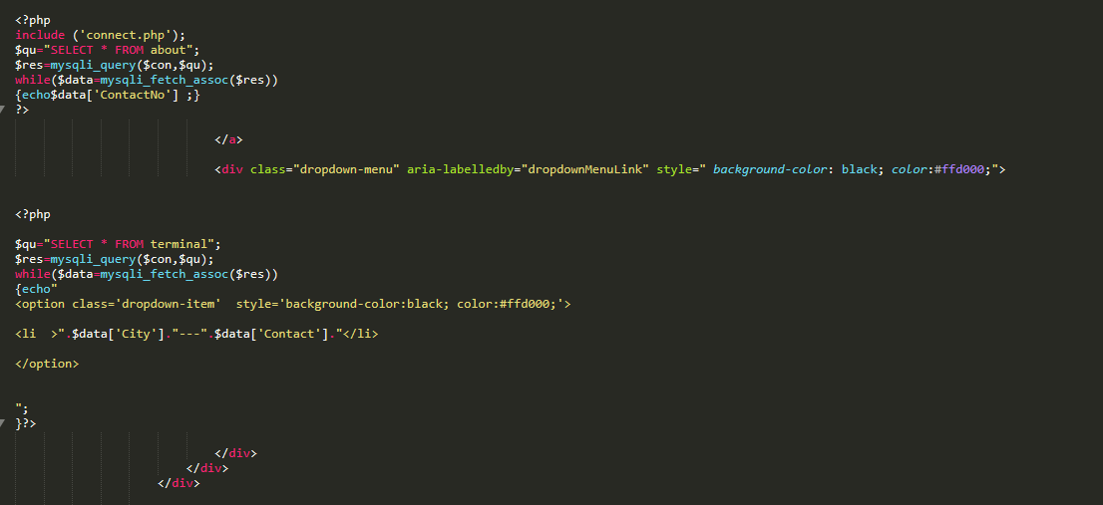

**About Page:-**

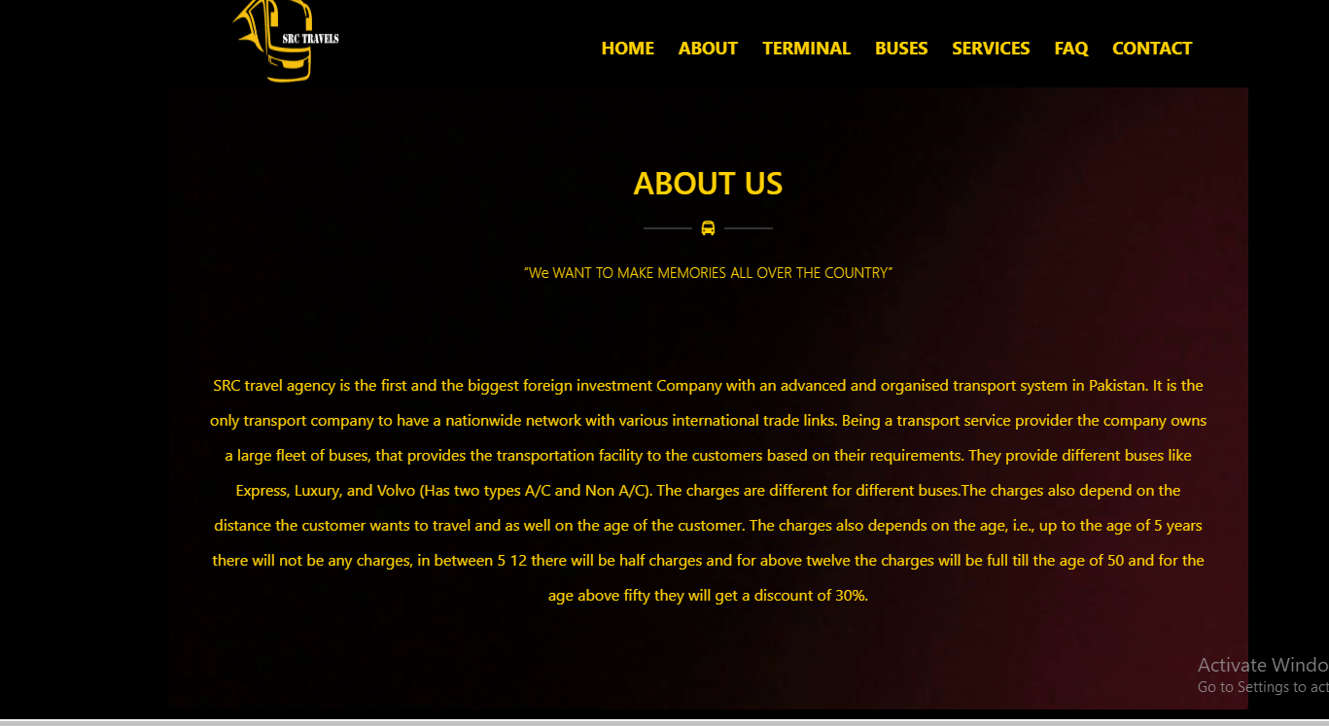

***Code Snippet***:

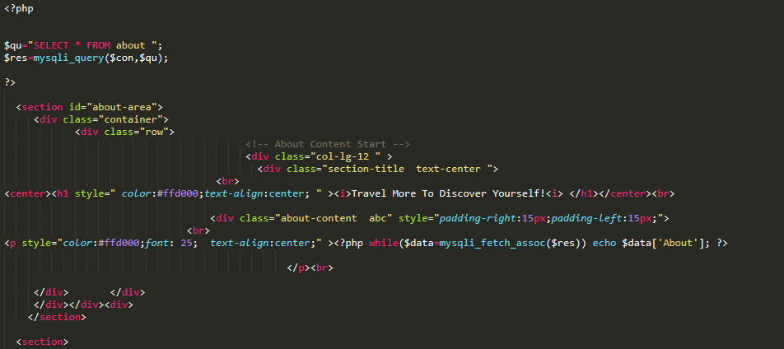

**Terminal Page:-**

This Page contain main terminal points details which are inserted in the database by the admin .

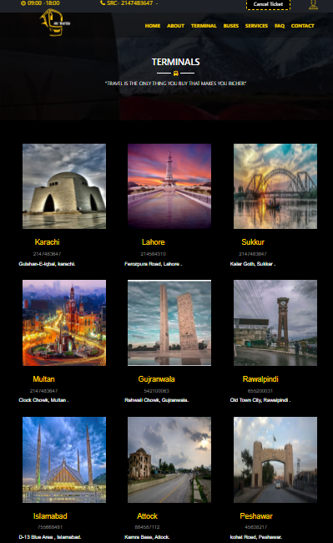

***Code Snippet***:

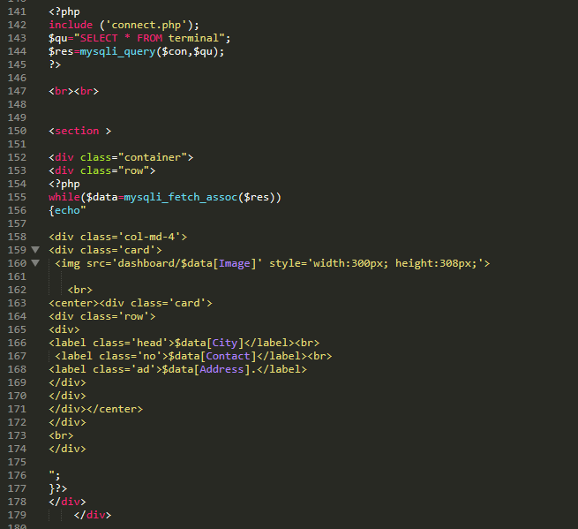

**Buses Page:-**

From this page customer can get detailed information about Buses & their routes and can book their ride.

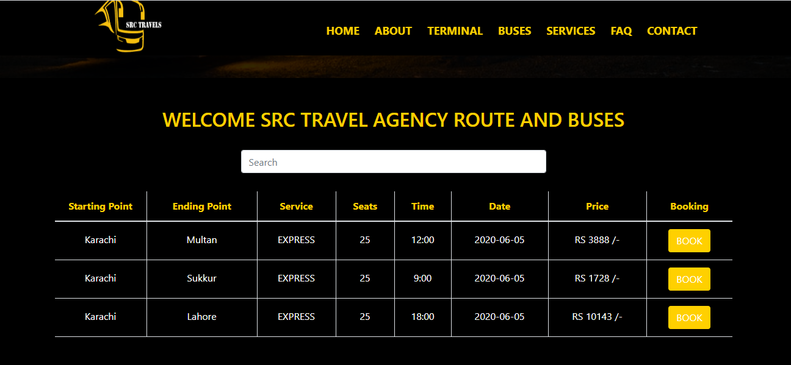

***Code Snippet***:

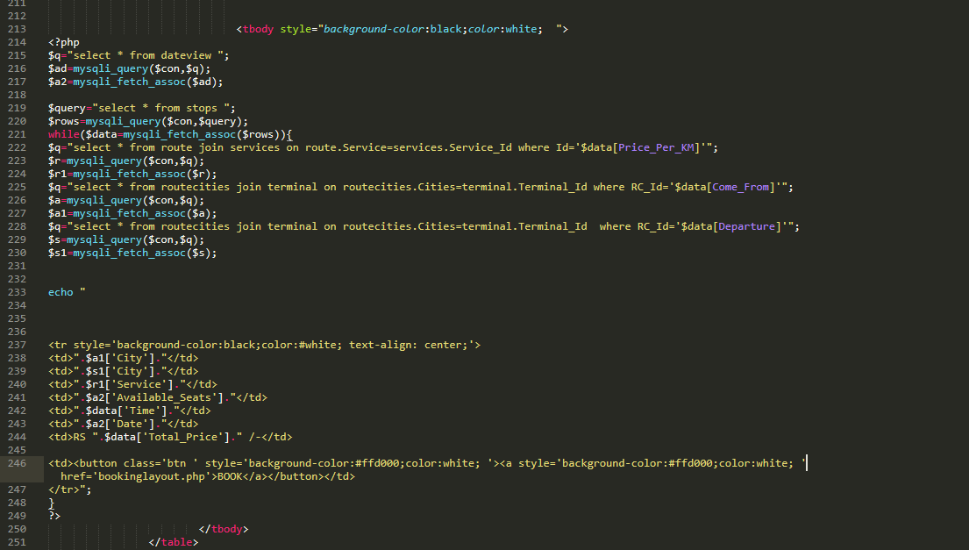

**Contact Page:-**

From this page customer can resolve quarries & can ask about services.

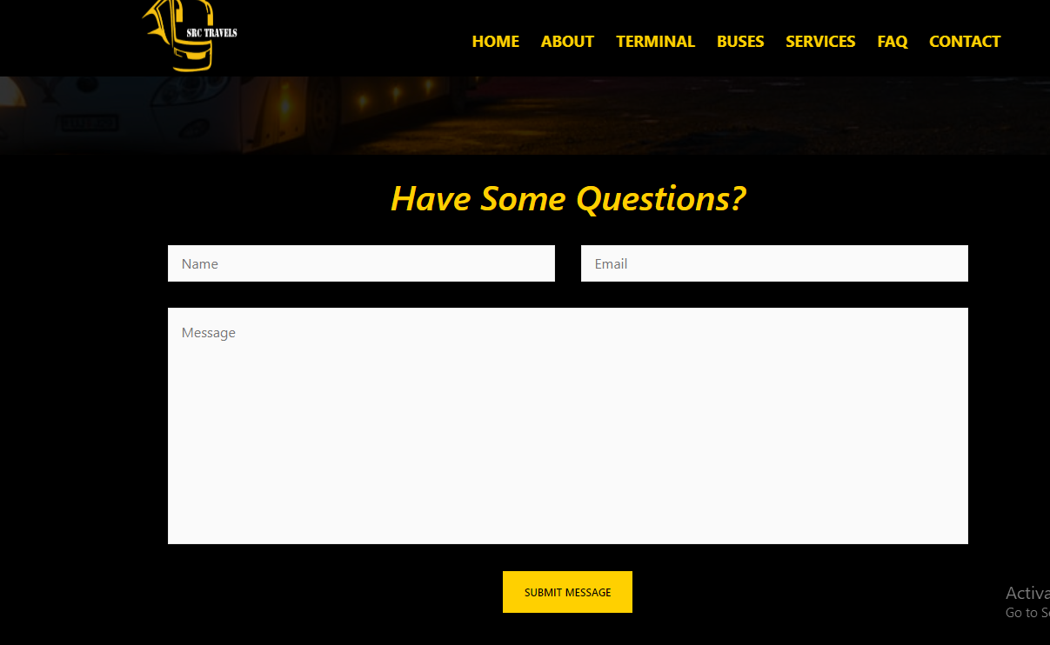

***Code Snippet***:

